**KIYALA HIGH SCHOOL**

**END OF TERM ONE ASSESSMENT TEST - 2024**

**HISTORY AND POLITICAL EDUCATION**

**Paper 1**

**S.1**

**2 Hours**

**INSTRUCTIONS**

* This paper consists of two sections **A** and **B**. It has ***four***examination items.
* Section **A** is ***compulsory***.
* Answer **one** item from section **B**
* Any additional item answered will not be ***scored***

**SECTION A**

*Attempt* **all** **the items** *in this section*

**Item 1**

The form one students of Masaka secondary School will compete in a school debate with a motion which states that ***“History subject is more important than any other subject in secondary level.”***

They were given to watch a video clip on how parliament conducts a debate as shown in one of the pictures below

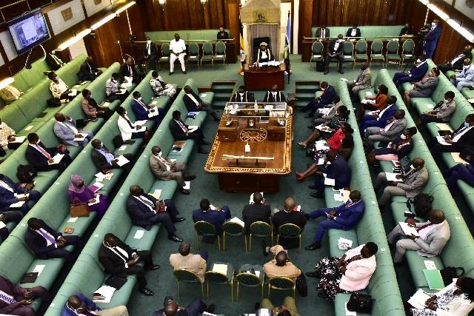 **Task**

Being one on the proposers side. Give ***eight (8)*** reasons to support the motion. ***(10 scores)***

**Item 2**

Mzee Odongo is an old man of 89 years old. He is a grand father to his only three grand sons Odongo, Opio who were born twins and Okello named after the twin brothers as the culture in Teso land. He always narrates the stories of long ago to his grandsons about the past events which happened in their times.

**Task**

Stating the method Mr Odongo used for passing his information, ***(1 score)***

List down ***five (5)*** merits and ***five (5)*** demerits of the methods of obtaining information which is used by Mzee Odongo. ***(10 scores)***

**SECTION B**

*Attempt only* **one (1)** *item in this section*

**Item 3**

The form one (1) students of Umoja Secondary school organized the study tour to visit Nyero Rock paintings to learn historical facts about the historical past which is famously known for its historical uniqueness and the mold of nature.

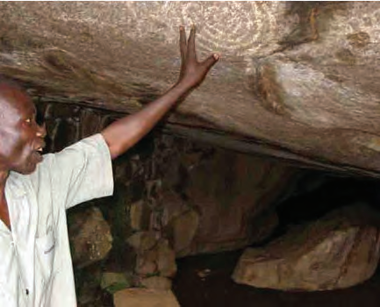

***Task***

As one among of the students who visited the historical site, identify ***five (5)*** reasons as to why you planned to visit Nyero Rock paintings and also ***five (5)*** challenges you faced while at the site. ***(10 scores)***

**Item 4**

Basing on the origin of man, human races are believed to have originated in different ways by the different theories like the traditional African creation stories, Biblical stories of creation, Darwin's theories of human evolution and many other more stories.

***Task***

Identify and note down one traditional African creation stories from any African societies and ethnic group you know. ***(10 scores)***

**END**